Industrial Internship Report on
”Button Controlled LED”
Prepared by
Khushi.N

Executive Summary
This report provides details of the Industrial Internship provided by upskill Campus and The IoT Academy in collaboration with Industrial Partner UniConverge Technologies Pvt Ltd (UCT).
This internship was focused on a project/problem statement provided by UCT. We had to finish the project including the report in 6 weeks’ time.
My project was (Tell about ur Project)
This internship gave me a very good opportunity to get exposure to Industrial problems and design/implement solution for that. It was an overall great experience to have this internship.

TABLE OF CONTENTS
1 Preface 3
2 Introduction 4
2.1 About UniConverge Technologies Pvt Ltd 4
2.2 About upskill Campus 8
2.3 Objective 9
2.4 Reference 9
2.5 Glossary 10
3 Problem Statement 11
4 Existing and Proposed solution 12
5 Proposed Design/ Model 13
5.1 High Level Diagram (if applicable) 13
5.2 Low Level Diagram (if applicable) 13
5.3 Interfaces (if applicable) 13
6 Performance Test 14
6.1 Test Plan/ Test Cases 14
6.2 Test Procedure 14
6.3 Performance Outcome 14
7 My learnings 15
8 Future work scope 16

PREFACE
Embedded systems have become an integral part of modern technology, playing a crucial role in controlling and automating a wide range of electronic devices. From simple household appliances to advanced industrial machines, embedded systems provide efficient, reliable, and real-time solutions. Understanding the basic concepts of embedded systems is therefore essential for building a strong foundation in electronics and engineering.
The project titled “Button Controlled LED System” is a simple yet effective demonstration of how embedded systems function in real-world applications. This project focuses on establishing an interface between input and output devices using a microcontroller. A push button is used as an input device, and an LED is used as an output device. The system is designed such that the LED responds to the action of the button, thereby illustrating the concept of digital input and output control.
The primary objective of this project is to gain practical knowledge of how hardware components interact with software instructions. It helps in understanding how signals are read from input devices, processed by the microcontroller, and then used to control output devices. This project also introduces basic programming logic, circuit design, and the importance of timing and control in embedded systems.
In addition to theoretical understanding, this project provides hands-on experience in assembling circuits, writing and uploading code, and troubleshooting common issues. It enhances problem-solving abilities and develops a clear understanding of the working principles of embedded systems. Such foundational knowledge is essential for progressing towards more advanced projects and applications in areas like automation, robotics, and the Internet of Things (IoT).
Overall, this project serves as a beginner-friendly introduction to embedded systems and demonstrates how simple components can be combined to create functional and meaningful electronic systems.

Introduction

About UniConverge Technologies Pvt Ltd
A company established in 2013 and working in Digital Transformation domain and providing Industrial solutions with prime focus on sustainability and RoI.
For developing its products and solutions it is leveraging various Cutting Edge Technologies e.g. Internet of Things (IoT), Cyber Security, Cloud computing (AWS, Azure), Machine Learning, Communication Technologies (4G/5G/LoRaWAN), Java Full Stack, Python, Front end etc.
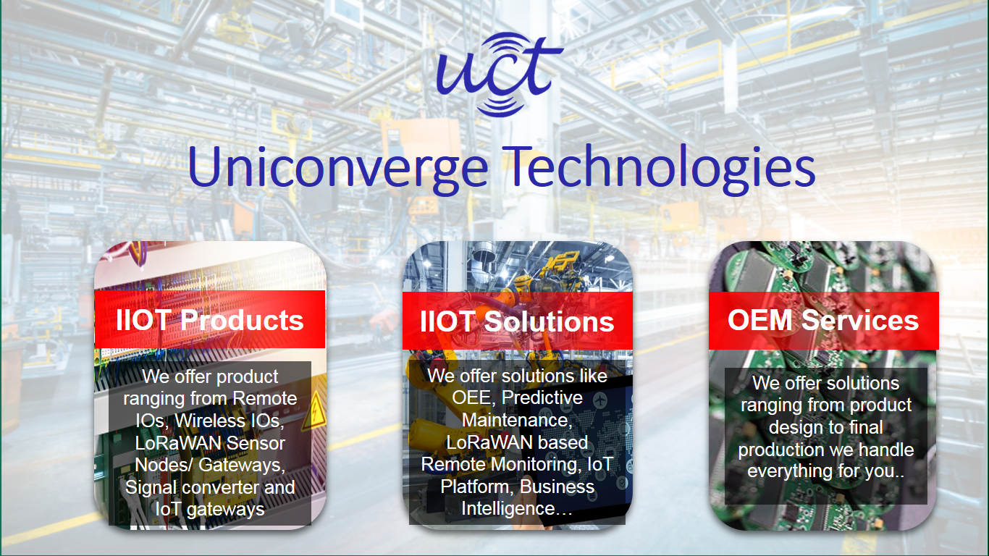
- UCT IoT Platform ()
UCT Insight is an IOT platform designed for quick deployment of IOT applications on the same time providing valuable “insight” for your process/business. It has been built in Java for backend and ReactJS for Front end. It has support for MySQL and various NoSql Databases.
- It enables device connectivity via industry standard IoT protocols - MQTT, CoAP, HTTP, Modbus TCP, OPC UA
- It supports both cloud and on-premises deployments.
It has features to
• Build Your own dashboard
• Analytics and Reporting
• Alert and Notification
• Integration with third party application(Power BI, SAP, ERP)
• Rule Engine

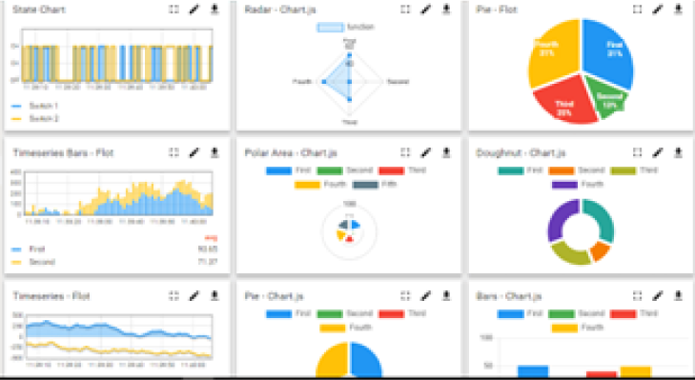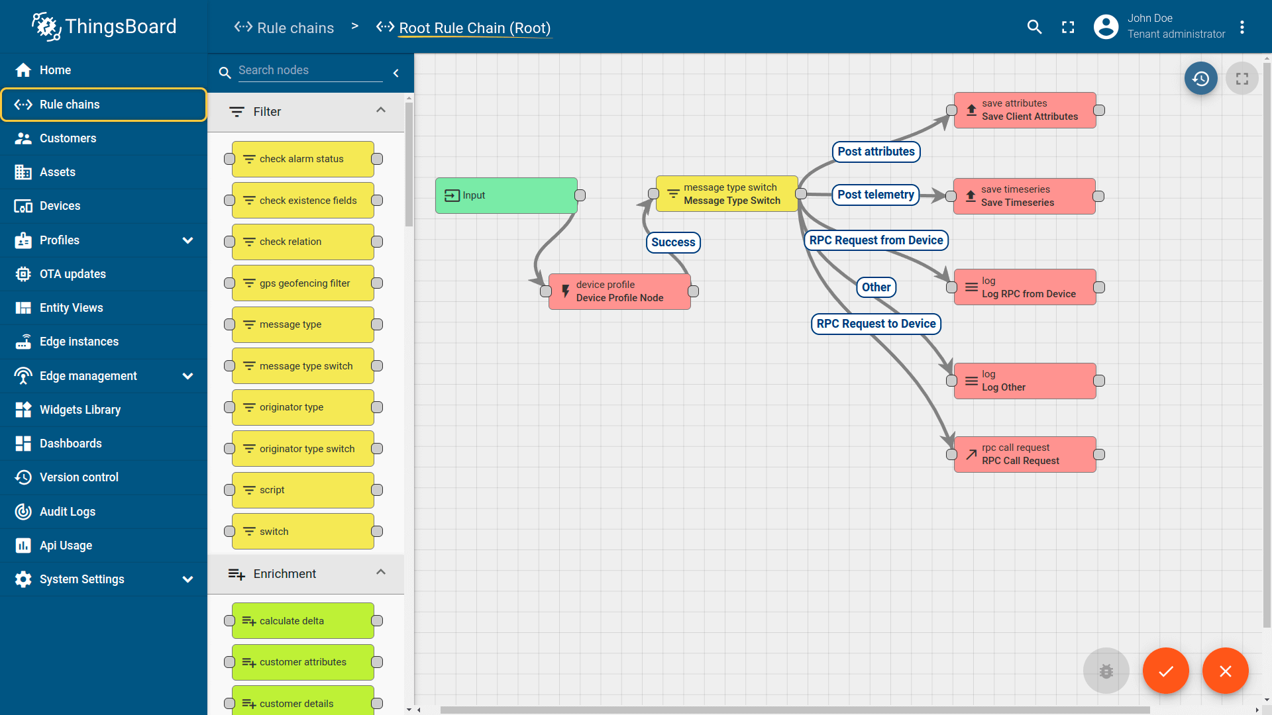

- Smart Factory Platform ()
Factory watch is a platform for smart factory needs.
It provides Users/ Factory
- with a scalable solution for their Production and asset monitoring
- OEE and predictive maintenance solution scaling up to digital twin for your assets.
- to unleased the true potential of the data that their machines are generating and helps to identify the KPIs and also improve them.
- A modular architecture that allows users to choose the service that they what to start and then can scale to more complex solutions as per their demands.
Its unique SaaS model helps users to save time, cost and money.
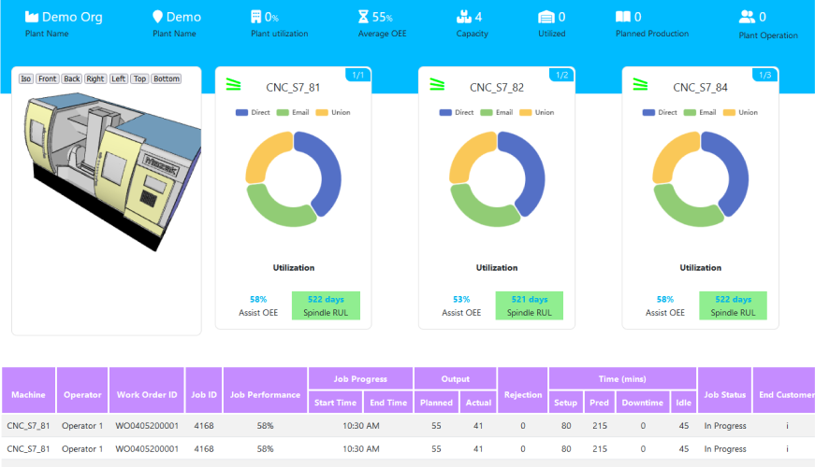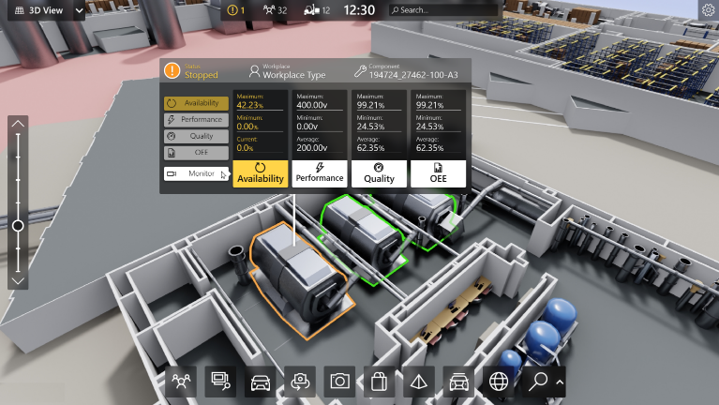

- 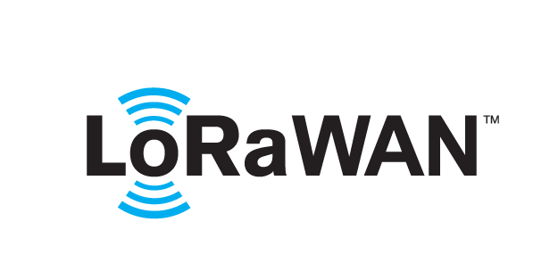 based Solution
UCT is one of the early adopters of LoRAWAN teschnology and providing solution in Agritech, Smart cities, Industrial Monitoring, Smart Street Light, Smart Water/ Gas/ Electricity metering solutions etc.
- Predictive Maintenance
UCT is providing Industrial Machine health monitoring and Predictive maintenance solution leveraging Embedded system, Industrial IoT and Machine Learning Technologies by finding Remaining useful life time of various Machines used in production process.
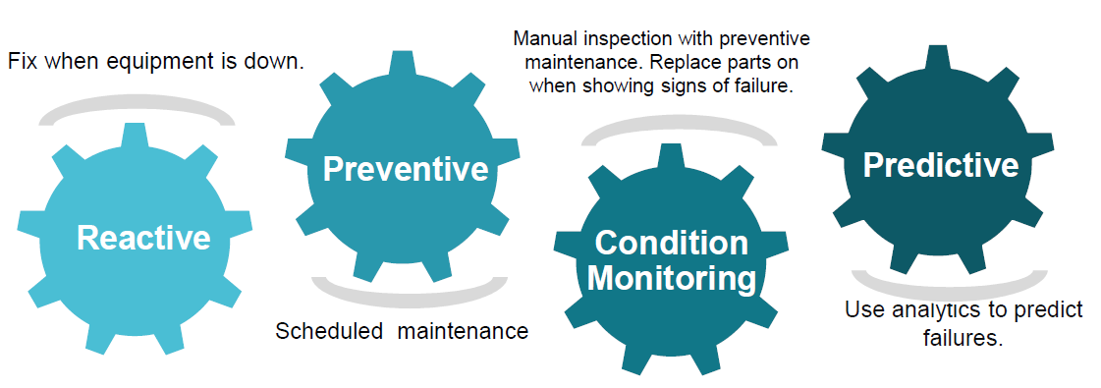

About upskill Campus (USC)
upskill Campus along with The IoT Academy and in association with Uniconverge technologies has facilitated the smooth execution of the complete internship process.
USC is a career development platform that delivers personalized executive coaching in a more affordable, scalable and measurable way.




Seeing need of upskilling in self paced manner along-with additional support services e.g. Internship, projects, interaction with Industry experts, Career growth Services
https://www.upskillcampus.com/
upSkill Campus aiming to upskill 1 million learners in next 5 year

The IoT Academy
The IoT academy is EdTech Division of UCT that is running long executive certification programs in collaboration with EICT Academy, IITK, IITR and IITG in multiple domains.

Objectives of this Internship program
The objective for this internship program was to
☛ get practical experience of working in the industry.
☛ to solve real world problems.
☛ to have improved job prospects.
☛ to have Improved understanding of our field and its applications.
☛ to have Personal growth like better communication and problem solving.

Reference

[1] eferences
- Arduino Programming in 24 Hours
– Covers basic Arduino concepts, digital input/output, and simple LED projects.
- Getting Started with Arduino
– Beginner-friendly guide explaining microcontrollers and basic circuits like LED and button control.
- Arduino IDE Documentation
– Official documentation for coding, uploading programs, and understanding functions like digitalRead() and digitalWrite()

Glossary
Term / Acronym | Full Form | Description
LED | Light Emitting Diode | A device that emits light when current flows through it; used as an output indicator.
GPIO | General Purpose Input Output | Pins on a microcontroller used for both input and output operations.
MCU | Microcontroller Unit | A small integrated circuit that controls the system based on programmed instructions.
VCC | Voltage Common Collector | The positive supply voltage given to the circuit.
GND | Ground | The reference point of the circuit that completes the electrical path.

Problem Statement

Problem Statement
To design and implement a simple embedded system where an LED is controlled using a push button, such that the LED turns ON when the button is pressed and turns OFF when it is released.

Short Explanation
This project focuses on understanding the basic concept of interfacing input and output devices using a microcontroller. The push button acts as an input device that sends a signal to the controller, while the LED acts as an output device that responds based on that signal.
When the button is pressed, the microcontroller detects the input and sends a command to turn ON the LED. When the button is released, the LED turns OFF. This demonstrates how embedded systems process user input and control hardware components in real time.

Existing and Proposed solution

Existing Solutions & Limitations
Existing systems use simple switches or fixed LED circuits. They lack programmability, have limited functionality, and cannot be easily modified or expanded.

Proposed Solution
A microcontroller-based system where a push button controls an LED. The LED turns ON when the button is pressed and OFF when released.

Value Addition
Can be enhanced with features like toggle control, multiple LEDs, brightness control, and future expansion to automation or IoT.

Code submission (Github link)
https://github.com/arduino/arduino-examples

Report submission (Github link) https://github.com/<your-username>/button-controlled-led

Proposed Design/ Model
The system consists of a push button (input), a microcontroller, and an LED (output). The push button is connected to a digital input pin of the microcontroller, while the LED is connected to a digital output pin.
When the button is pressed, the microcontroller reads the input signal and processes it according to the programmed logic. It then sends a signal to the LED to turn ON. When the button is released, the LED turns OFF.
Thus, the design follows a simple flow:
Input (Button) → Processing (Microcontroller) → Output (LED)

High Level Diagram (if applicable)
+-------------+ +------------------+ +-----------+
| Push Button| -----> | Microcontroller | -----> | LED |
| (Input) | | (Processing) | | (Output) |
+-------------+ +------------------+ +-----------+

Figure 1: HIGH LEVEL DIAGRAM OF THE SYSTEM

Low Level Diagram (if applicable)
+5V (VCC)
|
|
[Button]
|
|-------> Pin 2 (Input - Microcontroller)
|
[Resistor]
|
GND

Pin 13 (Output - Microcontroller)
|
[Resistor]
|
[LED]
|
GND

Interfaces (if applicable)

1. Block Diagram
The system consists of three main blocks: Input (Push Button), Processing Unit (Microcontroller), and Output (LED). The input signal from the button is processed by the microcontroller to control the LED.

2. Data Flow
The data flows in a simple sequence:
Button Press (Input Signal) → Microcontroller Processing → LED Output Response
The microcontroller continuously reads the input pin and updates the output accordingly.

3. Protocols
No external communication protocols are used in this system. Internal communication occurs through digital I/O logic levels (HIGH/LOW) within the microcontroller.

4. Flow Chart
Start → Initialize pins → Read button input →
If button pressed → LED ON →
Else → LED OFF → Repeat loop

5. State Machine
The system operates in two states:
- State 1: LED OFF (Button not pressed)
- State 2: LED ON (Button pressed)
Transition occurs based on button input.

6. Memory Buffer Management
This system does not require complex memory management. It uses simple variable storage to read input status and control output, as the data processing is minimal and real-time.

Performance Test

1. Identified Constraints
- Memory: Limited program memory of the microcontroller
- Speed (MIPS): Fast response required for button press
- Power Consumption: Should be low for efficient operation
- Accuracy: Correct detection of button press (no false triggering)
- Durability: Button should withstand repeated usage

2. Handling of Constraints in Design
- Memory: Used simple and minimal code (no extra libraries)
- Speed: Real-time polling ensures immediate LED response
- Power: Low-power components like LED and basic MCU used
- Accuracy: Debouncing logic (delay) avoids false signals
- Durability: Standard push button used for reliable operation

3. Test Results
- Response Time: LED turns ON/OFF instantly (<1 second delay)
- Accuracy: Stable output with no flickering after debouncing
- Power Usage: Very low, suitable for small embedded systems
- Reliability: Continuous operation without failure during testing

4. Impact & Recommendations
- Without debouncing → LED may flicker (accuracy issue)
- Poor wiring → signal noise can affect performance
- For improvement:
  - Use hardware debouncing (capacitor)
  - Use interrupts instead of polling for better efficiency
  - Use low-power modes for advanced applications

Test Plan/ Test Cases
Test Case | Input Condition | Expected Output
TC1 | Button not pressed | LED remains OFF
TC2 | Button pressed | LED turns ON
TC3 | Button pressed continuously | LED stays ON
TC4 | Button released | LED turns OFF
TC5 | Rapid button press/release | LED responds correctly without flickering

Test Procedure
- Connect the circuit properly (button, LED, microcontroller).
- Upload the program to the microcontroller.
- Power ON the system.
- Press the button and observe LED behavior.
- Release the button and observe changes.
- Repeat multiple times to check consistency.
- Perform rapid pressing to test stability.

Performance Outcome
- The LED responded correctly to all button inputs.
- The system showed fast response with negligible delay.
- No flickering observed due to proper logic handling.
- The system operated reliably and consistently during repeated tests.
- Power consumption remained low, suitable for embedded applications.

My learnings

This project helped in understanding the basic concepts of embedded systems, including interfacing input and output devices, programming a microcontroller, and designing simple circuits. It provided practical knowledge of how hardware and software work together to perform real-time operations.
Through this project, problem-solving skills and logical thinking were improved, along with hands-on experience in coding and circuit implementation. These skills form a strong foundation for advanced areas like automation, IoT, and embedded system design.
Overall, the knowledge gained from this project will be useful in building more complex systems and will support future career growth in electronics and technology-related fields.

Future work scope

The Button Controlled LED system can be further enhanced by adding advanced features and applications. It can be extended to control multiple LEDs or devices using different inputs. The system can be upgraded with toggle functionality and brightness control (PWM) for better user interaction.
It can also be integrated with sensors for automatic operation and expanded into home automation systems. By connecting it to the internet, it can be developed into an IoT-based remote control system using mobile applications.
Overall, this basic project can be scaled into more complex and real-world applications in automation, smart devices, and embedded system development.

